ANGLEŠČINA 7. RAZRED
2. preverjanje pred 2. pisnim ocenjevanjem znanja

1. What were they doing yesterday at 4 pm? Write 12 sentences (4 positive, 4 negative, 4 questions). Kaj so počeli včeraj ob 16. uri? Zapiši 12 povedi (4 trdilne, 4 nikalne, 4 vprašalne).
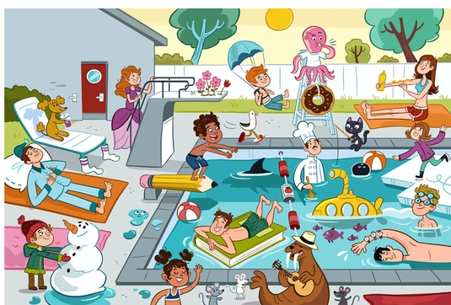

1. _________________________________________________________________________
2. _________________________________________________________________________
3. _________________________________________________________________________
4. _________________________________________________________________________
5. _________________________________________________________________________
6. _________________________________________________________________________
7. _________________________________________________________________________
8. _________________________________________________________________________
9. _________________________________________________________________________
10. ________________________________________________________________________
11. ________________________________________________________________________
12. ________________________________________________________________________

2. Complete the sentences by using the appropriate tenses. Dopolni povedi z ustreznim časom.
Primer: When I was waiting (wait) for the school bus, my friend saw (see) me.
a) The headmaster _______________________ (come) into the class while we _______________________ (have).
b) My parents _______________________ (get married) while they _______________________ (study) at university.
c) The farmer _______________________ (work) in the fields when the earthquake _______________________ (start).

3. Use the cues to find the words. Uporabi namige, da najdeš besedo, ki opisuje pojav.
The ground moves when this happens. E_______________________
This is a wind that goes round in circles. T_______________________
This is a very bad storm with strong winds and rain. H_______________________
This is when it rains a lot and the water from rivers goes into streets and houses. F_______________________
This is when hot lava comes out of a volcano. E_______________________
This is when snow moves on a mountain. A_______________________
This is when there is light in the sky which can burn things. L_______________________
This is when there is a big wall of water in the sea. T_______________________

4. Which room is it? Za katero sobo gre?
You have dinner in the _______________________________________________.
People plant flowers in the _______________________________________________.
You watch TV in the _______________________________________________.

5. Match the names with the pictures. Poveži besede s slikami.
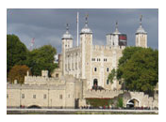
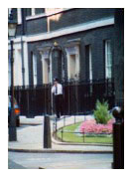
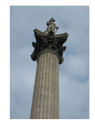
10 Downing Street Nelson’s Column Picadilly Circus
The Tower of London
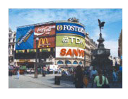

6. Put in “the” or nothing (-). Vstavi člen “the” ali pa nič, če ni potrebno (-).
_____ Asia _____ Blue Train Restaurant _____ Jenner’s Hotel
_____ Lake Michigan _____ Gobi Desert _____ Regent Street
_____ Mississippi _____ Whitehall Theatre _____ Egypt

7. Put in “a/an” or “the”. Vstavi “a/an” ali “the”.
I bought _____ new pair of shoes.
I saw _____ movie last night.
I don’t like _____ football.
I’d like _____ piece of cake. _____ cake you brought seems delicious.
Look at _____ woman over there! She’s _____ famous actress!

8. Fill in “somebody, anybody, nobody, something, anything, nothing”. Vstavi ustrezno besedo “somebody, anybody, nobody, something, anything, nothing”.

I’ve got ________________________ in my eye.
I don’t ________________________ from our class! Where are they?
Do you live ________________________ near Mandy?
My teacher asked me ________________________.
Can I have ________________________ to drink?
There’s ________________________ at the door.
I don’t know ________________________ about it.

9. Fill in the correct verb form (past simple, past continuous, present simple, present continuous). Vstavi ustrezno obliko glagola v pravilnem slovničnem času.
Last night, while I __________________________ (do) my homework, Angela __________________________ (call). She __________________________ (say) she __________________________ (call) me on her cell phone from her biology classroom. I __________________________ (ask) her if she __________________________ (wait) for class, but she __________________________ (say) that the professor __________________________ (be) at the front of the hall lecturing while she __________________________ (talk) to me.
Today __________________________ (be) the second day of my trek around Mount Annapurna. I __________________________ (be) exhausted and my legs __________________________ (shake). I __________________________ (hope) I’m able to complete the trek. My feet __________________________ (kill) me and my toes __________________________ (bleed), but I still __________________________ (want) to continue.
Nepal __________________________ (be) a fascinating country, but I __________________________ (have) a great deal to learn – everything __________________________ (be) so different here! I __________________________ (try) to adapt to the new way of life.

10. “should” or “shouldn’t”? Fill in. Vstavi “should” ali “shouldn’t”.
You have a good job, you ___________________ change it.
You ___________________ drink so much coffee, it’s bad for your blood pressure.
The government ___________________ help people.
It’s an incredible film, you ___________________ watch it.
Do you think I ___________________ apply for that new job?

